The George Washington University
School of Engineering and Applied Science
Department of Computer Science

Progress Report #4

for the

Voice Launch

By

Amir Raminfar

CSci 196-11
Senior Computer Science Design Project

Abstract of Progress Report #4 for
Voice Launch
by
Amir Raminfar

This report summarizes the progress which has been completed to date for Voice Launch. Voice Launch is a speech recognition program that will recognize and launch a selection of at least fifteen applications. The user will need to record a number of phrases and associate each phrase with an application. The expected accuracy is equal to or greater than 80%. To launch an application via voice, the user’s phrase is recorded and passed to the recognition thread. The recognition thread will find the most similar item from the library by comparing the recorded phrase to all other templates in the library. A template holds features of a previously recorded phrase and is stored in the library. The user is prompted with a confirmation dialog prior to launching any application. If the found application is not what the user desired, then he or she can click or say no and the next best application is chosen. If, after three attempts, the correct application was not found, then no application is launched.

The project consists of nine main modules. The modules include Record, Save to Disk, Insert to Library, Sample, Recognize, Continuous Recording and Launch Application. Furthermore, the project consists of a Library and Graphical User Interference. The program will require a machine of at least 800 MHz and at least 256 MB of RAM. A microphone is required for recording speech and speakers are recommended for playback.

The project will require 36 weeks to complete and will need an estimated 462 hours of labor at an estimated labor cost of $17,640. A working prototype is estimated to cost $59,270. An economic analysis has determined that if one-million units are sold over the Internet at a cost of $18.60 per unit, this will result in a profit of $11,445,064. To date an expenditure of $15,025 has been used to develop the prototype and this report.

The current status of the prototype is 100% completed. All modules have been completed with 80% success rate. Since the project was ahead of schedule, some new features were added. Continuous recording was completed successfully and integrated into the application. However, expected results for continuous recording are not as high as hoped.

TABLE OF CONTENTS

Abstract............................................................................................................................................ii
List of Figures.................................................................................................................................iv
List of Tables...................................................................................................................................v
1. Introduction 1
2. Design of the Project 2
3. Module List 4
4. Tests to Verify the Design 6
5. Gantt Chart 9
6. Labor Costs by Week 10
7. Economic Analysis 12
8. Status Matrices 14
9. Conclusion 18
10. References 19
Appendix A – Task Table
Appendix B – Gantt Chart
LIST OF FIGURES

Figure 1 – Block Diagram of Modules 3
Figure 2 – Cumulative Labor Cost Graph 11

LIST OF TABLES

Table 1 - Module List 5
Table 2 - Verifications 6
Table 3 - Labor Costs by Week 10
Table 4 - Prototype Cost 12
Table 5 - Unit Costs 13
Table 6 - Outlined Matrix 14
Table 7 - Designed Matrix 15
Table 8 - Constructed Matrix 15
Table 9 - Tested Matrix 16
Table 10 - Integrated Matrix 16
Table 11 - Documented Matrix 17
Table 12 - Total Matrix 17

Introduction

This project uses a speech recognition algorithm known as Dynamic Time Warping (DTW) to allow users to launch applications of their choice via voice. It will support up to fifteen words which the user can choose, and will be at least 80% accurate.
Chapter 2 discusses the design of this project in further detail and presents a block-diagram of all modules. Chapter 3 displays and explains the length of each module. This chapter also discusses the time needed to construct each module. Subsequently, chapter 4 discusses what tests are needed to verify that each module and all modules together will function correctly.
Chapter 5 explains the Gantt chart which was produced by Microsoft Project. Chapter 6 discusses costs by week and provides a detailed table and graph. Chapter 7 describes how much the prototype will cost, as well as how much profit can be acquired if one-million units were to be sold. In addition, this chapter outlines a summary of how much the prototype will cost and the unit costs.
Finally, in chapter 8, seven matrices are presented. Each matrix provides progress about one aspect of this project. The seven matrices are outlined, designed, constructed, tested, integrated, documented and total progress completed.

Design of the Project

This project consists of nine modules. There are four modules which together record the user’s voice, extract its features and finally insert them into the library. There are another three modules needed to sample, recognize and launch the application which is mapped to the recognized phrase. The program will also have Graphical User Interface (GUI) and Library modules. It is required for the user to build a collection of WAV files that can be inserted into the library. The items in the library are called templates. Each template holds features extracted from the WAV file and the application which will be launched for that WAV file. The audio is recorded in mono with a sample rate of 16,000 samples per second. The length of each WAV file is two-seconds. The extracted features are the number of zero-crossings for each interval. There will be further detail provided on the Feature Extraction module.
As illustrated in Figure 1 and as previously stated, the Record module records the WAV file. Once the user is satisfied with the resulting WAV file, it will be written to disk in the Save to Disk module. The newly recorded WAV file is inserted into a collection of WAV files and its features are extracted in the Feature Extractor module. This module finds the number of zero-crossing for each interval. The length of each WAV file is two-seconds or 2,000ms. There will be a total of 100 intervals, each having the length 20ms. However, before calculating the zero-crossings, the WAV file’s excessive background noise is first removed. The noise is removed by first scanning and finding the maximum sample located in the first 100ms interval. Anything less than the maximum value is zeroed out in the beginning and the end of the phrase. The features along with the application mappings are passed to the Insert Library module which saves all necessary information to disk. The Sampling module, similar to the Record module, is responsible for recording the user’s phrase and sending it to the Recognize module. The Recognize module, which is the most complicated module, is responsible for recognizing and finding the closest match. The Recognize module will first extract the sample’s features by passing it to the Feature Extractor. After all the features are extracted, the Recognize module will use the DTW algorithm to find the best-matched template and finally, the last module will launch the user’s application which was pre-selected.
The GUI module is where all the events are triggered. Depending on the event, the GUI calls either the Record or Sample module. The GUI also has access to the library for maintenance purposes. The library keeps a record of WAV-file-to-application mappings and a folder to store the WAV files. The Recognize module will need to access the library to recognize which phrase the user spoke and to retrieve which application is mapped to that phrase.

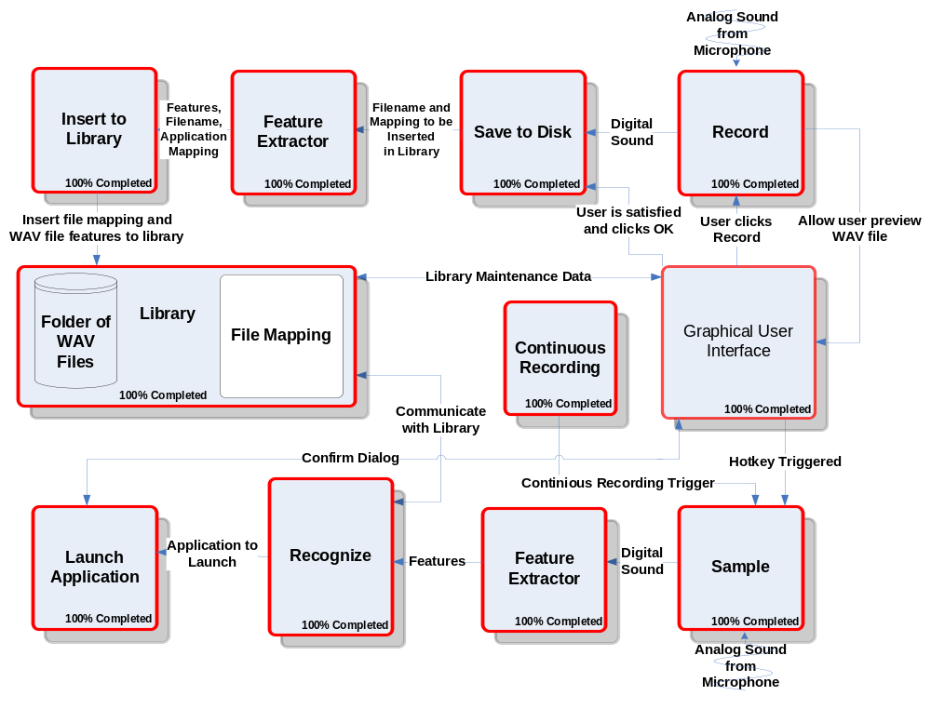
Figure 1 – Block Diagram of Modules

Currently, all modules have been completed, tested and some additional improvements have been added. Some new features include starting the recognition phase via voice. The user can now say “computer,” as opposed to using the mouse or keyboard to initiate the recognition phase. Figure 1 shows the Continuous Recording module and how it communicates with the Sample module. The Continuous Recording module is able to trigger events so that the recognition phase can initiate. A cancel button has also been added to the confirmation dialog which stops the confirmation process without launching any applications.

Module List

Table 1 summarizes how much time and money was needed to implement each module. The recoding module captures sound from the microphone. The Library module is responsible for inserting and retrieving templates from the library which is located on disk. The microphone also provides sound for the sampling module which calls the recognition module. It was estimated that the Recognition module will take the majority of time. However, after constructing the majority of all modules it was shown that the majority of time for constructing this project will be allocated for the Graphical User Interface. The initial estimated length of code was 7,100 lines, but after completing most modules it was clear only 3,290 lines of code were needed.
Table 1 - Module List
Module Name | % Comp. | Called By | It Calls | Lines Est. | Lines Coded | Lines Rem. | Hours Coded | Hours Rem. | $ to Code
RECORD | 100% | GUI | GUI | 500 | 150 | 0 | 3 | 0 | $ 120
SAVE TO DISK | 100% | Library | - | 600 | 50 | 0 | 1 | 0 | $ 40
INSERT TO LIBRARY | 100% | Library | - | 1,000 | 200 | 0 | 4 | 0 | $ 160
SAMPLE | 100% | GUI | Recognize | 500 | 150 | 0 | 2 | 0 | $ 80
RECOGNIZE | 100% | Sample | Launch Application | 1,500 | 490 | 0 | 11 | 0 | $ 440
LAUNCH APPLICATION | 100% | Recognize | - | 100 | 50 | 0 | 1 | 0 | $ 40
FEATURE EXTRACTOR | 100% | Library/Recognize | - | 1,000 | 200 | 0 | 5 | 0 | $ 200
LIBRARY | 100% | - | - | 300 | 300 | 0 | 4 | 0 | $ 160
GUI  5 | 100% | User | - | 1,600 | 1,700 | 0 | 34 | 0 | $ 1,360
TOTAL | 100% |  |  | 7,100 | 3,290 | 0 | 65 | 0 | $2,600

Tests to Verify the Design

Table 2 describes the tests needed to verify that each module functions correctly independently. The recording module can be tested by first recoding a sound sample and then verifying the sample by playing it. If the recording module is successful, it can be used in conjunction with the writing WAV file module to test that both work together properly. A third-party WAV player can be used to verify that the WAV file was properly written to disk. Inserting WAV files to the library will be tested by inspecting the text file. Each WAV-to-application mapping will be written on a separate line. One can view the text file to verify that it is correct. Recording a sample is similar to the Record module and it can use the same method to verify its correctness.
The recognition module can be tested with some simple templates. Lastly, the Launch Application module can be tested by providing the module with a string to launch.

Table 2 - Verifications

Module Name | Input | Expected Result | Status
Record | Analog Sound | To be digitized and played successfully after recording. | Pass
Record | Analog Sound | Test with a quiet room. | Pass
Record | Analog Sound | Record with microphone. | Pass
Record | Analog Sound | Record with other sources besides a microphone. | Pass
Save to File | Sound from Record module | Digital sound to be saved on disk and played through a third-party WAV player. | Pass
Feature Extractor | WAV file | Successfully divided into 100 uniform intervals. | Pass
Feature Extractor | WAV file | The correct number of zero-crossings for 500 samples should be extracted. | Pass
Feature Extractor | WAV file | The correct number of zero -crossings for all interval should be extracted successfully. | Pass
Feature Extractor | WAV file | The correct number of average time for each interval is returned. | Pass
Insert to Library | WAV file from save to disk module | Open and write to file successfully. | Pass
Insert to Library | WAV file from save to disk module | Extract should be successfully written to file. | Pass
Sample | Analog Sound | Digitized and played successfully after recording. | Pass
Recognize | Digital sound from sample module | Stepped through the matrix successfully. | Pass
Recognize | Digital sound from sample module | Matrix created successfully. | Pass
Recognize | Digital sound from sample module | Template with best match and within threshold is returned. | Pass
Launch Application | Application address from recognize module | Application should be launched. | Pass
Library | WAV files | All templates should be returned in a matrix. When needed it should return all WAV files to the GUI. | Pass
GUI | Events are triggered by user | Buttons can trigger a number of events ranging from recording to recognition. | Pass
GUI | Hotkey | Hotkey should trigger the recording to being | Pass
GUI | Events are triggered by user | Buttons can trigger a number of events ranging from recording to recognition. | Pass
Accuracy | Application name via voice x 10 time | At least 8 of the 10 tries are successful | Pass
Accuracy | The above test times done with 5 different application names | At least 8 of the 10 tries are successful for each try | Pass

The completed project can be tested by performing all tasks possible. To do this, a user can provide a phrase or word so that it can be captured. Once the user is satisfied with the WAV file, it is saved to disk, and its features are extracted and inserted into the library. The user specifies which application will be launched in relation to the newly recorded WAV file. This process will be repeated at least ten times. Once ten words have been added to the library, the same user initializes the recognition phase and he or she is prompted with a confirmation dialog. If the correct application was found then the user can say or click yes. Otherwise the next best application will be found.
As was shown in Table 2, all tests have been passed successfully. The project has been tested with a library of fifteen words and results were as expected.

Gantt Chart

Appendix A shows a table produced by Microsoft Project. This table includes costs, hours worked, start and end times, duration and resource name for each task. Appendix B includes a Gantt chart, providing a detailed timeline to build a working prototype. As shown in the table, from September 1, 2004 to May 4, 2005 a total time of 462 hours and cost of $17,640 is needed to complete this project.

Labor Costs by Week

The labor for the prototype is estimated to cost $17,640 in a period of 36 weeks. The first ten weeks were mostly focused on designing and analyzing, whereas after ten weeks programmers started building the prototype. Table 3 illustrates labor costs by week in more detail. Figure 2 displays a graph of the data given by Table 3. The X-axis represents time and the Y-axis represents cumulative cost. Compared to initial estimates, an amount of $7,000 less was needed to complete the prototype. Furthermore, in the month of December and January, the prototype was completed and for the remaining weeks, time was allocated for testing and documenting the project.
Table 3 - Labor Costs by Week
Week # | ESTIMATED LABOR COSTS | ESTIMATED CUMM COSTS | ACTUAL COSTS | ACTUAL CUMM COSTS | PROJECTED LABOR COSTS | PROJECTED CUMM COSTS
0 | $0 | $0 | $0 | $0
1 | $135 | $135 | $225 | $225
2 | $700 | $835 | $635 | $860
3 | $700 | $1,535 | $665 | $1,525
4 | $1,150 | $2,685 | $215 | $1,740
5 | $300 | $2,985 | $315 | $2,055
6 | $700 | $3,685 | $450 | $2,505
7 | $300 | $3,985 | $920 | $3,425
8 | $400 | $4,385 | $135 | $3,560
9 | $200 | $4,585 | $435 | $3,995
10 | $200 | $4,785 | $1,180 | $5,175
11 | $200 | $4,985 | $665 | $5,840
12 | $400 | $5,385 | $660 | $6,500
13 | $700 | $6,085 | $985 | $7,485
14 | $700 | $6,785 | $1,200 | $8,685
15 | $200 | $6,985 | $1,175 | $9,860
16 | $100 | $7,085 | $175 | $10,035
17 | $700 | $7,785 | $315 | $10,350
18 | $500 | $8,285 | $455 | $10,805
19 | $1,087 | $9,372 | $320 | $11,125
20 | $1,043 | $10,415 | $820 | $11,945
21 | $700 | $11,115 | $380 | $12,325
22 | $700 | $11,815 | $210 | $12,535
23 | $1,000 | $12,815 | $455 | $12,990
24 | $750 | $13,565 | $160 | $13,150
25 | $955 | $14,520 | $0 | $13,150
26 | $1,000 | $15,520 | $730 | $13,880
27 | $1,200 | $16,720 | $0 | $13,880
28 | $805 | $17,525 | $280 | $14,160
29 | $400 | $17,925 | $280 | $14,440
30 | $950 | $18,875 | $415 | $14,855
31 | $955 | $19,830 | $170 | $15,025 | $170 | $15,025
32 | $900 | $20,730 |  |  | $700 | $15,725
33 | $1,000 | $21,730 |  |  | $415 | $16,140
34 | $826 | $22,556 |  |  | $1,115 | $17,255
35 | $895 | $23,451 |  |  | $385 | $17,640
36 | $385 | $23,836 |  |  | $0 | $17,640

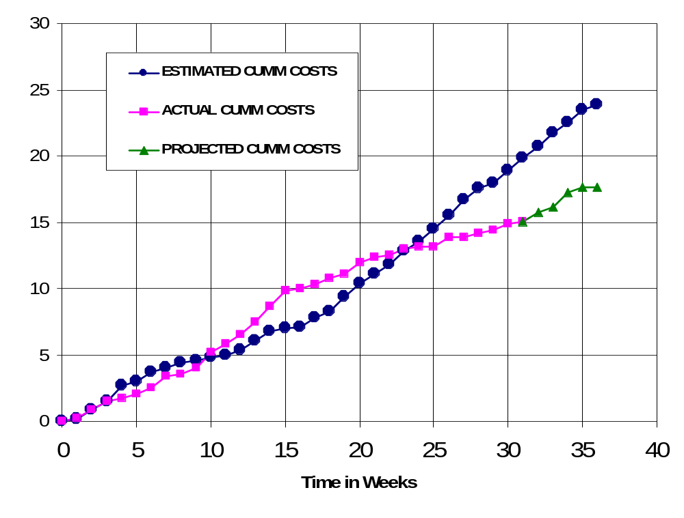
Figure 2 – Cumulative Labor Cost Graph

Economic Analysis

Table 4 illustrates in detail how much the prototype will cost. Overhead, A&G costs and profit were added to initial estimates. The total cost of the prototype is $59,270, a difference of $20,000 more than originally estimated.
Table 4 - Prototype Cost

PROTOTYPE COSTS
 | Labor Rate | Initial Est. Hours | Initial Est. Cost | Current Est. Hours | Current Est. Cost
System Analyst | $45.00 | 215 | $9,686 | 113 | $5,085
Programmer | $40.00 | 268 | $10,720 | 68 | $2,720
Test Programmer | $35.00 | 31 | $1,085 | 91 | $3,185
Technical Writer | $35.00 | 67 | $2,345 | 190 | $6,650
TOTAL |  | 581 | $23,836 | 462 | $17,640
DIRECT OVERHEAD @ 100% |  |  | $23,836 |  | $17,640
SUBTOTAL |  |  | $47,673 |  | $35,280
A&G COSTS @ 40% |  |  | $19,069 |  | $14,112
SUBTOTAL |  |  | $66,742 |  | $49,392
PROFIT @ 20% |  |  | $13,348 |  | $9,878
TOTAL COST OF PROTOTYPE |  |  | $80,090 |  | $59,270

Table 5 describes unit costs if the corporation was to act as a retailer on the Internet. This calculation assumes 1,000,000 units will be sold. The first 20,000 units will recoup the amount of money that the prototype costs. The price of each copy was chosen to be $18.60.

Table 5 - Unit Costs

SOLD BY CORPORATION AS A RETAILER ON THE INTERNET
 | Initial Estimate |  |  | Current Estimate
PROTOTYPE COSTS | $80,090 |  |  | $59,270
INSTALL MACHINE AND SOFTWARE | $50,000 |  |  | $50,000
SUBTOTAL | $130,090 |  |  | $109,270
OVERHEARD @ 200% | $260,180 |  |  | $218,541
SUBTOTAL | $390,269 |  |  | $327,811
DOCUMENTATION | $0 |  |  | $0
PACKAGING SUBTOTAL | $0 |  |  | $0
SUBTOTAL | $390,269 |  |  | $327,811
A&G @ 40% | $156,108 |  |  | $131,124
SUBTOTAL | $546,377 |  |  | $458,936
PROFIT @ 20% | $109,275 |  |  | $91,787
SUBTOTAL | $655,653 |  |  | $550,723
 |  | Initial Estimate |  | Current Estimate
 | # of copies | Price/Copy | Total Profit | Price/Copy | Total Profit
Total to Sell | 1,000,000
Recoup Prototype Costs | 100,000 | $6.56 | $109,275 | $5.51 | $91,787
Excess Profit from Recoup | 100,000 | $12.04 | $1,204,347 | $13.09 | $1,309,277
Remainder to Sell | 900,000 | $18.60 | $16,740,000 | $18.60 | $16,740,000
 |  | Minus 40% for A&G | $6,696,000 | Minus 40% for A&G | $6,696,000
Subtotal |  |  | $10,044,000 |  | $10,044,000
Total Profit |  |  | $11,357,623 |  | $11,445,064

Status Matrices

The following seven tables display the progress which has been completed on each module. Table 6 displays the amount of time each module has been planned and outlined to date. Table 7 shows the amount of time needed to design each module. Table 8 displays the amount of time needed to construct each module. Table 9 and Table 10 illustrate the amount of time needed to test each module separately and all modules together. Table 11 displays the amount of time to document the entire project including this report and the user manual. Finally, Table 12 totals all matrices and class time together.

Table 6 - Outlined Matrix

OUTLINED
MODULE NAME | INIT. EST. HRS. | CUR. EST. HRS. | HRS SPENT TO DATE | % COMPT. | EST. HRS TO COMP.
RECORD | 8 | 8 | 8 | 100% | 0
SAVE TO DISK | 7 | 5 | 5 | 100% | 0
INSERT TO LIBRARY | 5 | 5 | 5 | 100% | 0
SAMPLE | 3 | 3 | 3 | 100% | 0
RECOGNIZE | 12 | 5 | 5 | 100% | 0
LAUNCH APPLICATION | 2 | 2 | 2 | 100% | 0
FEATURE EXTRACTOR | 0 | 2 | 2 | 100% | 0
LIBRARY | 2 | 2 | 2 | 100% | 0
GUI | 2 | 2 | 2 | 100% | 0
TOTALS | 41 | 34 | 34 | 100% | 0

Table 7 - Designed Matrix

DESIGNED
MODULE NAME | INIT. EST. HRS. | CUR. EST. HRS. | HRS SPENT TO DATE | % COMPT. | EST. HRS TO COMP.
RECORD | 6 | 5 | 5 | 100% | 0
SAVE TO DISK | 7 | 4 | 4 | 100% | 0
INSERT TO LIBRARY | 6 | 8 | 8 | 100% | 0
SAMPLE | 4 | 5 | 5 | 100% | 0
RECOGNIZE | 12 | 25 | 25 | 100% | 0
LAUNCH APPLICATION | 3 | 4 | 4 | 100% | 0
FEATURE EXTRACTOR | 0 | 3 | 3 | 100% | 0
LIBRARY | 2 | 2 | 2 | 100% | 0
GUI | 4 | 4 | 4 | 100% | 0
TOTALS | 44 | 60 | 60 | 100% | 0

Table 8 - Constructed Matrix

CONSTRUCTED
MODULE NAME | INIT. EST. HRS. | CUR. EST. HRS. | HRS SPENT TO DATE | % COMPT. | EST. HRS TO COMP.
RECORD | 40 | 3 | 3 | 100% | 0
SAVE TO DISK | 20 | 1 | 1 | 100% | 0
INSERT TO LIBRARY | 28 | 4 | 4 | 100% | 0
SAMPLE | 40 | 2 | 2 | 100% | 0
RECOGNIZE | 120 | 10 | 10 | 100% | 0
LAUNCH APPLICATION | 20 | 1 | 1 | 100% | 0
FEATURE EXTRACTOR | 0 | 5 | 5 | 100% | 0
LIBRARY | 4 | 4 | 4 | 100% | 0
GUI | 15 | 35 | 35 | 100% | 0
TOTALS | 287 | 65 | 65 | 100% | 0

Table 9 - Tested Matrix

TESTED
MODULE NAME | INIT. EST. HRS. | CUR. EST. HRS. | HRS SPENT TO DATE | % COMPT. | EST. HRS TO COMP.
RECORD | 6 | 5 | 5 | 100% | 0
SAVE TO DISK | 4 | 1 | 1 | 100% | 0
INSERT TO LIBRARY | 4 | 9 | 9 | 100% | 0
SAMPLE | 4 | 2 | 2 | 100% | 0
RECOGNIZE | 10 | 5 | 5 | 100% | 0
LAUNCH APPLICATION | 3 | 1 | 1 | 100% | 0
FEATURE EXTRACTOR | 0 | 7 | 7 | 100% | 0
LIBRARY | 2 | 10 | 10 | 100% | 0
GUI | 4 | 10 | 10 | 100% | 0
TOTALS | 37 | 50 | 50 | 100% | 0

Table 10 - Integrated Matrix

INTEGRATED
MODULE NAME | INIT. EST. HRS. | CUR. EST. HRS. | HRS SPENT TO DATE | % COMPT. | EST. HRS TO COMP.
RECORD | 4 | 5 | 5 | 100% | 0
SAVE TO DISK | 4 | 1 | 1 | 100% | 0
INSERT TO LIBRARY | 3 | 9 | 9 | 100% | 0
SAMPLE | 1 | 1 | 1 | 100% | 0
RECOGNIZE | 6 | 1 | 1 | 100% | 0
LAUNCH APPLICATION | 2 | 1 | 1 | 100% | 0
FEATURE EXTRACTOR | 0 | 2 | 2 | 100% | 0
LIBRARY | 2 | 4 | 4 | 100% | 0
GUI | 20 | 6 | 6 | 100% | 0
TOTALS | 42 | 30 | 30 | 100% | 0

Table 11 - Documented Matrix

DOCUMENTED
MODULE NAME | INIT. EST. HRS. | CUR. EST. HRS. | HRS SPENT TO DATE | % COMPT. | EST. HRS TO COMP.
RECORD | 15 | 21 | 19 | 90.5% | 2
SAVE TO DISK | 13 | 11 | 9 | 81.8% | 2
INSERT TO LIBRARY | 15 | 15 | 12 | 80.0% | 3
SAMPLE | 15 | 11 | 11 | 100.0% | 0
RECOGNIZE | 25 | 18 | 15 | 83.3% | 3
LAUNCH APPLICATION | 15 | 11 | 11 | 100.0% | 0
FEATURE EXTRACTOR | 0 | 15 | 12 | 80.0% | 3
LIBRARY | 1 | 12 | 10 | 83.3% | 2
GUI | 2 | 22 | 16 | 72.7% | 6
TOTALS | 101 | 136 | 115 | 84.6% | 21

Table 12 - Total Matrix

TOTAL
MODULE NAME | INIT. EST. HRS. | CUR. EST. HRS. | HRS SPENT TO DATE | % COMPT. | EST. HRS TO COMP.
RECORD | 79 | 47 | 45 | 95.7% | 2
SAVE TO DISK | 55 | 23 | 21 | 91.3% | 2
INSERT TO LIBRARY | 61 | 50 | 47 | 94.0% | 3
SAMPLE | 67 | 24 | 24 | 100.0% | 0
RECOGNIZE | 185 | 64 | 61 | 95.3% | 3
LAUNCH APPLICATION | 45 | 20 | 20 | 100.0% | 0
FEATURE EXTRACTOR | 0 | 34 | 31 | 91.2% | 3
LIBRARY | 13 | 34 | 32 | 94.1% | 2
GUI | 47 | 79 | 73 | 92.4% | 6
CLASS TIME | 87 | 87 | 72 | 82.8% | 15
TOTALS | 639 | 462 | 426 | 92.2% | 36

Conclusion

The previous chapters demonstrated how the speech recognition project was outlined, designed, constructed, tested, integrated and documented. Currently, the project has been successfully completed. The cost of the prototype is projected to be $59,270 which is about $20,000 less compared to initially estimated cost. By the next progress report, it is planned for the user manual to be completed.
References

Anonymous, “Dragon NaturallySpeaking 7” <http://www.scansoft.com/naturallyspeaking/>
Henry, David, “David Henry Company”, < http://www.davidhenryco.com/>
Hill, Pamela, “IBM ViaVoice”, <http://www-306.ibm.com/software/voice/viavoice/>
Lyon, Jack, “Realize Software”, <http://www.realizesoftware.com/>
Spencer, Chris, “Wizzard Software Corp.”, <http://www.wizzardsoftware.com/>
Ultimate Interactive, “Ultimate Interactive Desktops Inc.” <http://www.voicestudio.us/>

Appendix A – Gantt Chart

